**NIP : 1.09.01521 _ SENIN, 13 NOVEMBER 2023 / 17.00 WIB (SEBELUM)**

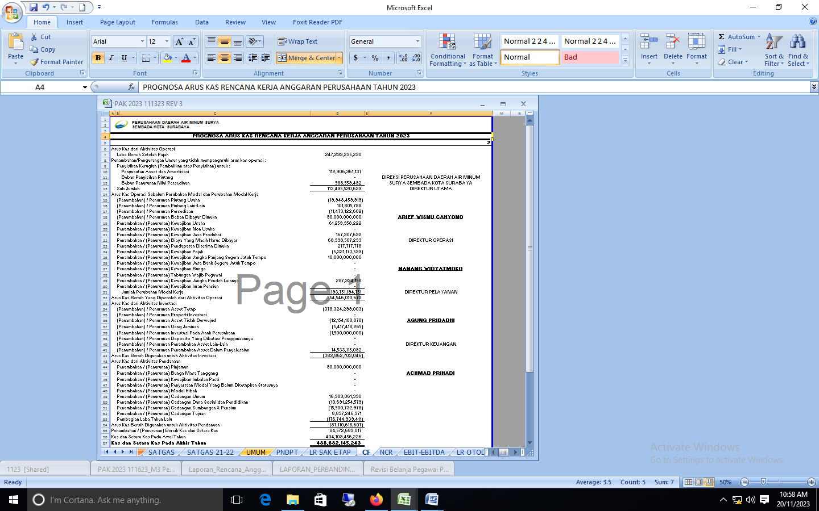

**NIP : 1.09.01521 _ SENIN, 13 NOVEMBER 2023 / 23.18 WIB (SETELAH)**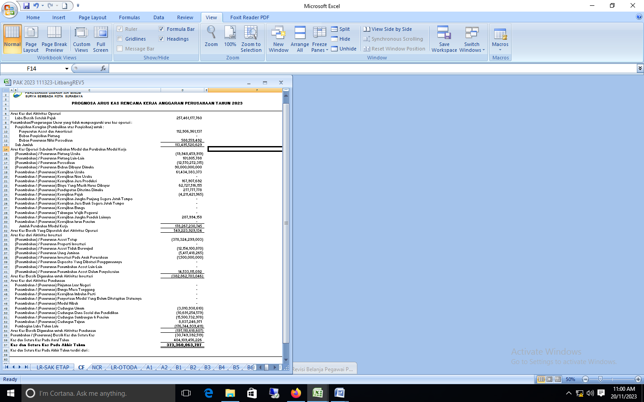

**NIP : 1.09.01521 _ SENIN, 7 NOVEMBER 2023 / 17.00 WIB (SEBELUM)**

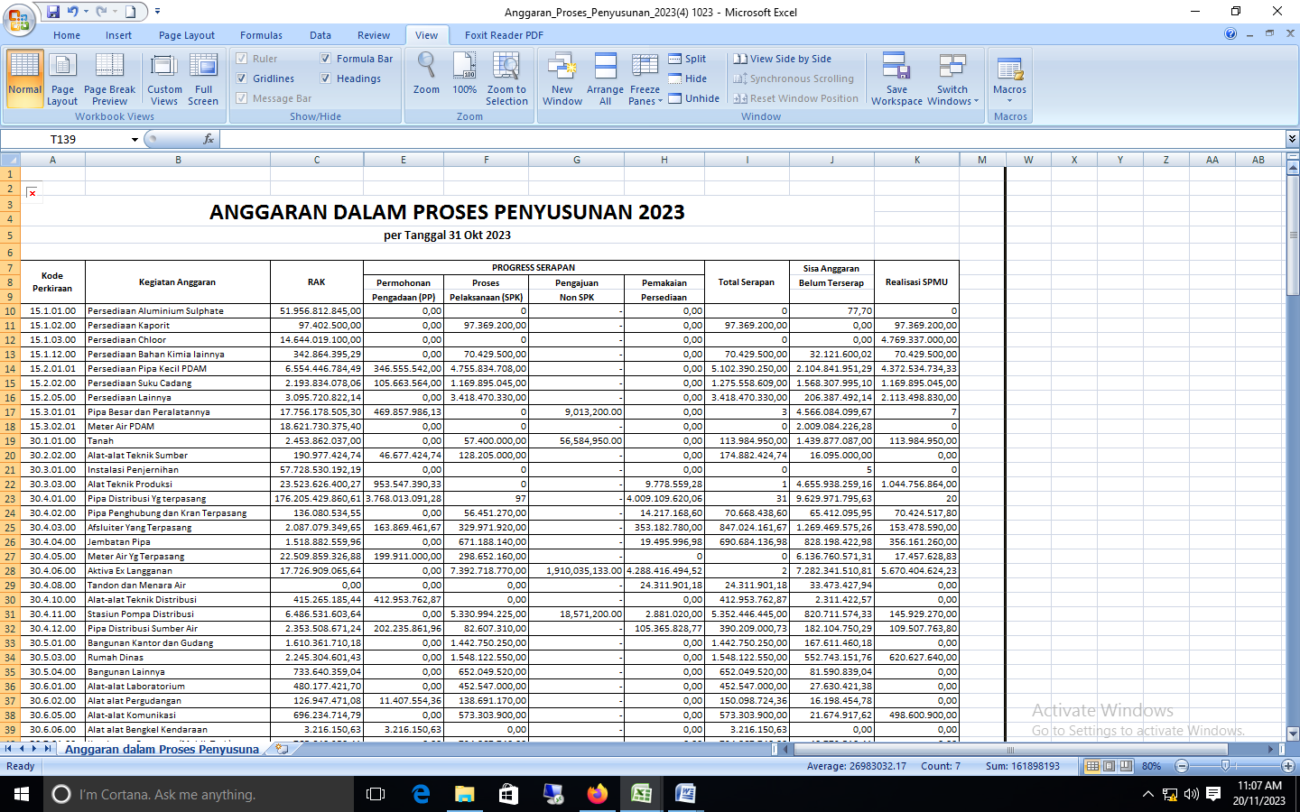

**NIP : 1.09.01521 _ SENIN, 7 NOVEMBER 2023 / 17.47 WIB (SETELAH)**

