14/11/2023_1.06.01346_17.00 WIB (sebelum

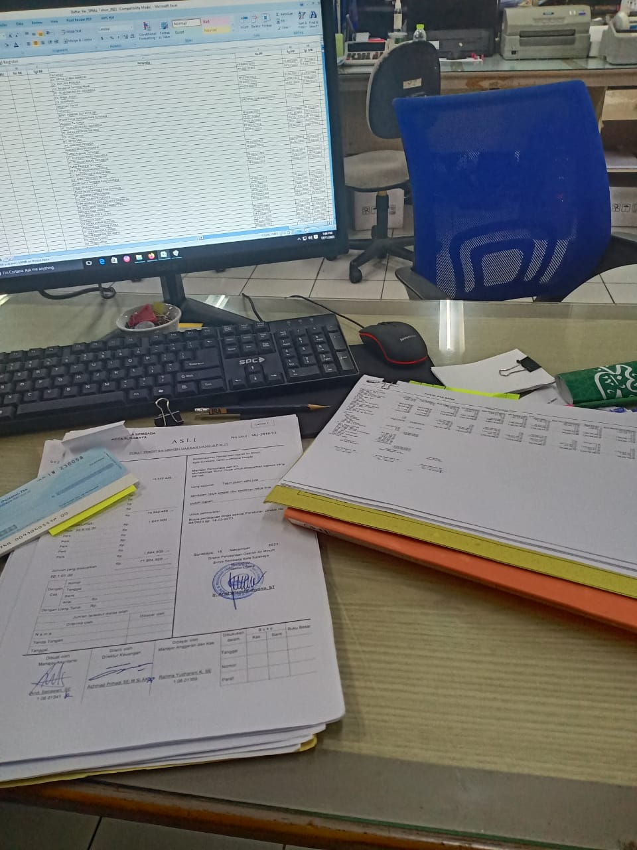

14/11/2023_1.06.01346_17.46 WIB (sesudah)

