**NIP 1.17.01719 - SENIN, 13 NOVEMBER 2023 / 17.00 WIB (SEBELUM)**

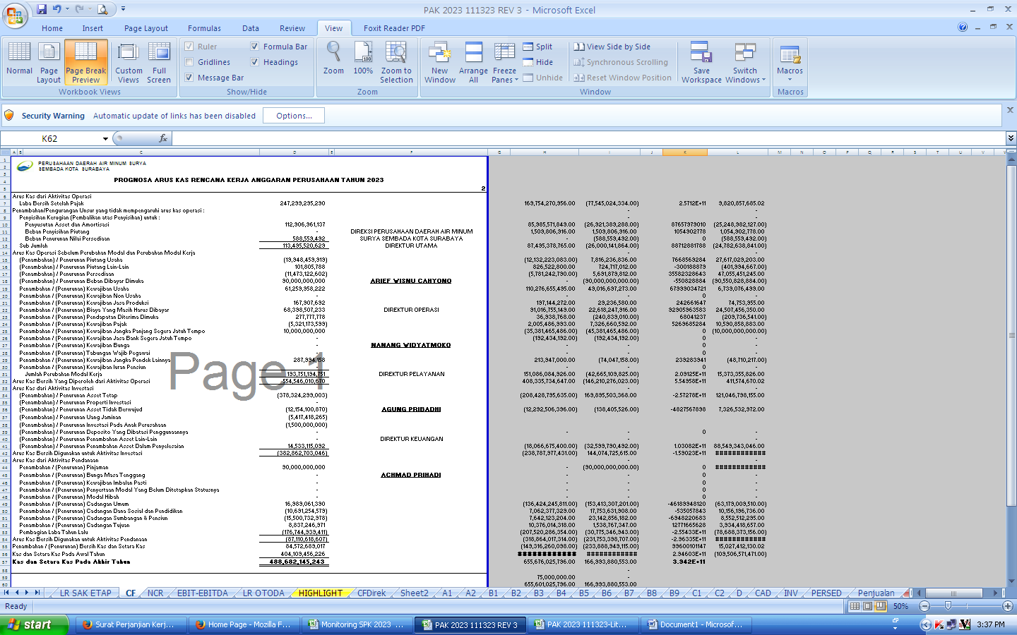

**NIP 1.17.01719 - SENIN, 13 NOVEMBER 2023 / 23.25 WIB (SETELAH)**

